**上 海 交 通 大 学 试 卷 （ 期末 ）**

（ 2021 至 2022 学年 第 1 学期）

班级号_______________________ 学号 姓名____________

课程名称 计算机系统工程 成绩____________

# Problem 1: File System (25’)

Xiaohong wrote an inode-based file system called NaiveFS. She formats one of her disk partitions as NaiveFS and mounts it to "/". NaiveFS matches the inode-based file system we learned in CSE classes, with the following parameters:

* The size of each inode is 256 Bytes.
* The size of each data block is 512 Bytes.
* An inode contains 56 pointers, with the first 54 pointers directly pointing to the data blocks, the next 1 pointer pointing to an indirection block and the last 1 pointer pointing to a double-indirect block.
* The size of each data block pointer is 4 bytes.

The detailed structure of an inode in NaiveFS is shown in the following table:

|  |  |  |
| --- | --- | --- |
| **Name** | **Size (Bytes)** | **Description** |
| inode ID | 8 | inode identifier |
| Size | 8 | File size |
| Type | 1 | File Type |
| Padding | 3 | Alignment padding |
| RefCount | 4 | Reference count of this inode |
| Atime | 4 | Last access time of this inode |
| Mtime | 4 | Last data modification time of this inode |
| Block Pointers | 4*56 | Block pointers of this inode |

*Table-1 inode design in NaiveFS*

1. Xiaohong has a file "/mnt/hdd/cse-notes.txt", where "/mnt/hdd" is mounted as an ext4 file system. She hopes to create a hard link from "/cse-notes.txt" to "/mnt/hdd/cse-notes.txt". Can she succeed? Why? (4’)

No. Hard link shares the same inode, which is not shared across file systems.

2. Xiaohong creates a symbolic link from "/lab-symbolic.tar.gz" to "/lab.tar.gz". Please describe the read and write sequence of inode and data during **open("/lab-symbolic.tar.gz")**. E.g., read XXX inode, write XXX inode, read XXX data, write XXX data. (Suppose the file system is mounted using the options to record atime for files, but not to record atime for directories) (4’)

read "/" inode → read "/" data → read "/lab-symbolic.tar.gz" inode → read "/lab-symbolic.tar.gz" data → write "/lab-symbolic.tar.gz" inode → read "/" inode → read "/" data → read "/lab.tar.gz" inode

3. Suppose the file write order in NaiveFS is: update size → allocate new blocks → write new data. Please list at least **two** inconsistent cases after crash. (4’)

1. File size is updated, but points to a block not belonging to this file
2. File size is updated, but data in the newly allocated block has not been written

4. Alice tries to copy a video (~20MB) to NaiveFS, but she found that NaiveFS does not support files of such size currently. Can you provide at least **two** solutions to make NaiveFS support storing the video? You are free to change any parameter of NaiveFS. (4’)

Larger block size, more double-indirect blocks

5. For a file with a content length of 224,256 Bytes, please calculate the metadata size caused by NaiveFS. You should consider the space occupied by the inode and all the indirect blocks. (4’)

inode: 256B

indirect blocks: (1+2)*512B=1536B

double indirect blocks: 1*512B=512B

total: 2304 B

6. Reducing file system metadata size is important for performance. The smaller the metadata is, the more possible it is cached in the DRAM and does not need to load from the slow disk. For large files, many indirection blocks would be used as metadata. Can you figure out a way to optimize metadata size for large files? (Hint: if the file can be stored sequentially on the disk...) (5’)

Extent based: do not maintain mapping for each block, but store each range as two numbers(理解是：将block-id与每一个block存储的文件对应的data的索引范围存储起来)

# Problem 2: MapReduce and Graph (24’)

Xiaohong hopes to use MapReduce (MR) to run a Social Arithmetic algorithm for a very large graph, which is stored as an adjacent list (vertex, weight, [friends]).

Below is a sequential version of the Social Arithmetic program.

|  |
| --- |
| Compute(v):  1 foreach n in v.friends:  2 like += n.weight / n.edges; |

1. Please write the Map and Reduce function, respectively, in order to exploit parallelism over MR. You may also use pseudocode. (8’)

(助教给的参考答案)

Map(V):

1 foreach v in V:

2 Output(v.weights / v.edges, [v.friends]);

Reduce([{v.weights / v.edges, [friends]}]):

1 foreach pair in list:

2 foreach friend in [friends]:

3 friend.like += v.weights / v.edges;

2. MR workers communicate with the master via Remote Procedure Calls (RPCs). Should RPCs in MR guarantee idempotence? Why? (4’)

Not necessary. Because mappers/reducers are stateless.

3. Failures are common in datacenters. How can MR detect and tolerate worker failures? (4’)

Heartbeat and re-execution of workers.

4. Xiaohong uses GFS for MR. A GFS typically consists of a master and multiple chunkservers. How does GFS handles master and chunkserver failures? (4’)

Three replicas for GFS masters and chunkservers.

5. Bob suggests Xiaohong to use a graph-friendly framework such as Pregel. What are Pregel's advantages for graph processing? (at least two) (4’)

Pregel's advantages:

1) Vertex-centric programming is natural to graph algorithms.

2) Bulk Synchronous Parallel (BSP) is faster for iterative computing.

# Problem 3: Paxos (25’)

Here is the pseudocode for **Paxos**, we assume all the servers are both acceptors and proposers.

|  |
| --- |
| **States**  **n0: the proposal number of the proposer**  **v0: the chosen value of the proposer**  **np: highest prepare seen**  **na, va: highest accept seen**  **Proposer**  **propose(v):**  **1  choose n0 > np**  **2  send prepare(n0) to all servers including itself**  **3  if prepare_ok(na; va) from majority:**  **4     v0 = va with highest na; choose own v otherwise**  **5     send accept(n0; v0) to all**  **6     if accept_ok(n0) from majority:**  **7        send decided(v0) to all**  **Acceptor**  **acceptor’s prepare(n) handler:**  **1  if n > np**  **2     np = n**  **3     reply prepare_ok(na; va)**  **acceptor’s accept(n; v) handler:**  **1  if n >= np**  **2     np = n**  **3     na = n**  **4     va = v**  **5     reply accept_ok(n)** |

1. Could Paxos successfuly decide a value when 6 servers fails in a cluster of 9 servers? How many server failures could be tolerated **at most** by Paxos in a cluster of 9 servers? (5')

No. 4.

1. The CAP theorem states that it is impossible for a distributed system to simultaneously guarantee **C**onsistency, **A**vailability, and **P**artition tolerance.
   1. What should the proposer do if there is no majority replying accept_ok in propose(v) line 5? (2')
   2. Which property of CAP will be sacrificed using your solution in a)? Please give an example to explain your answer. (4')
2. Retry propose(v)
3. Availability.

Example:

1. S0 prepare(0), S0 S2 prepare_ok
2. S1 prepare(1), S1 S2 prepare_ok
3. S0 accept(0), fail
4. S0 prepare(2), S0 S2 prepare_ok
5. S1 accept(1), fail
6. S1 prepare(3), S1 S2 prepare_ok
7. ...
8. Which states (*n0, v0, np, na, va*) **must** be persisted for consistency? Please describe how to restore the states above that do **not** need to be persisted? (5')

must persist: np, na, va

n0 = np + 1

v0 = va with highest na from prepare_ok?(na; va)

1. A server lost its persisted state on the disk, and it tries to restore the states by copying from another server. Is it correct? If so, why? If not, please give an example to explain your answer. (5')

No.

Example:

1. S0 proposes v0
2. S0, S1 accept v0, S2 network failure
3. S1 loses disk data
4. S0 network failure
5. S1 restores disk data by copying from S2
6. A learner wants to get a decided value by asking the value of *va* from a randomly picked server. Is it correct? If so, why? If not, how to get the decided value? (5')

No.

Solution 1: add a state vd to remember the decided value after receiving decided(v0)

Solutoin 2: send prepare(0) to all servers

# Problem 4: Transaction Concurrency Control (25’)

Xiaohong is developing a ticketing system for a railway company, the main business of which includes ticket purchasing and refunding. When purchasing a ticket, a user would select one seat and the amount of the remaining ticket will be declined. The refunding is the opposite.

Assuming xiaohong has developed one basic function to handle the requests of ticket purchase (descript). The read of remaining ticket amount (descript) in transaction descript is annoted as descript, and descript as write event.

1. Here's one implementation of *ticket_purchase.* Please point out the problems when different threads run them in parallel. After that, give some solutions you've learned in class to manage the transaction concurrency control. (4')

|  |
| --- |
| **void ticket_purchase() { // purchase one ticket**  **tmp = read(ticket_amount)**  **if (tmp == 0) { return Fail }**  **write(ticket_amount, tmp - 1)**  **}** |

**A: If multiple requests come in parallel, and may let the ticket_amount < 0. After that, user could always purchase more ticket.**

**And more than one user could have the same seat.**

1. Now Xiaohong uses transactions to handle the ticketing system, and adopts conflict graph to show the data dependency of the transactions, assisting to check out whether one schedule is conflict serializable. We denote *ticket_num* as descript and if we have two conflict transaction operations descript, one directed edge would start from descript to descript in the conflict graph.

Now please draw the conflict graph of descript , and explain why this schedule is not conflict serializable (4')

**A:**

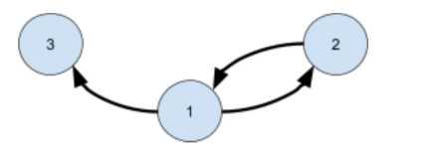

**There exists one circle in conflict graph**

1. Xiaohong wants to adopt 2PL to control the concurrency in the system, while 2PL may have introduce deadlock. Please give two solutions to avoid deadlock and explain why these solutions can help to avoid deadlock (4').

**A:Two phase lock is pessimistic. Before proceed, each transaction has to conflicting transaction to release the lock, which will introduce loop waiting.**

**To solve it, we could:**

* **Acquire lock in pre-defined order.**
* **Detect dead lock via conflict graph.**
* **Using heuristic to pre-abort.**

1. There are 3 transactions descript executing under a OCC protocol we've learned in class. We assume each transaction will perform three steps in order:

start the transaction(***S***), start validation (***V***) , finish commit (***F***). That is, transaction descript must perform descript in order.

For example, the below figure shows the process, and the events sequence is descript. Note that the commit opearation is atomic (i.e., execute in a critical section). If one transaction meets the requirement of OCC protocol, this transaction could commit (i.e., validate successfully).

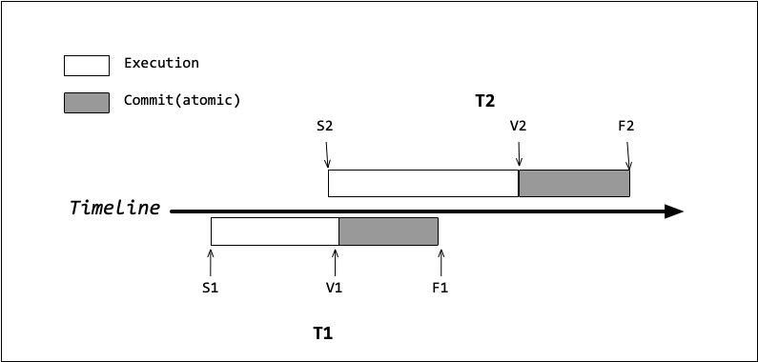

Suppose three transactions have the following read/write sets:

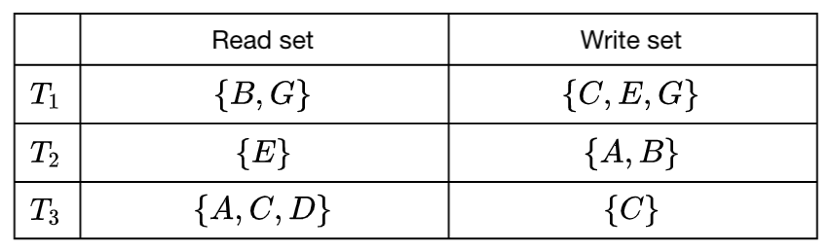

Now consider the following sequence of events descript .Please answer which transactions commit successfully and which do not.

( Note that the changes is invisible until the transactions come to ***F*** stage. )

1. Does descript commit successfully ? **If not, point out the conflict transaction.** (3')

**A:Not successfully. T1 conflict with T2.**

1. Does descript commit successfully ? **If not, point out the conflict transaction.** (3')

**A:Successfully.**

1. Does descript commit successfully ? **If not, point out the conflict transaction.** (3')

**A:Not successfully. T3 conflict with both T1 and T2**

1. Now Xiaohong is going to log all of the actions in transactions. Assume one crash occurs, and Xiaohong notices the event sequence is shown as the figure below:

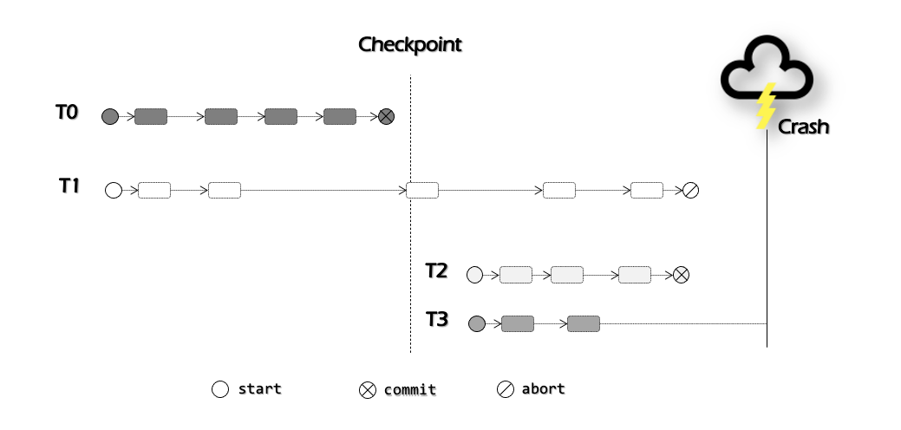

1. With the help of undo/redo log, the transactions could recover from the crash by conducting undo/redo operations. Please explain why we need checkpoint in logging, and briefly describe how to add one checkpoint while logging. (4')

**A:**

* **Avoid log size from growing too large**
* **Avoid recovery from a blank state**

**How to checkpoint:**

**The checkpoint will be recorded into log while no actions are in progress. This checkpoint record contains a list of all transactions that are running in process and pointers to their most recent log records. Afterwards, the checkpoint root is atomically updated to the new checkpoint record.**

1. According to the figure, descript could **do nothing** to recover from the crash. Now please point out what operations other three transaction should do (e.g., T1: do nothing). (3')

**A: T1: undo ; T2: redo; T3: do nothing / undo**

